2D Side Scrolling Video Game

Research & Technology Assessment

2015 - 2016

Gavin Hickey - X00109563

**Application Area**

In this project our aim was that we would create a side scrolling arcade style game. The game is planned to have a co-op functionality allowing players to play together, this we had planned to stand out among other video game projects created in the past. The programs we will be using will vary as time goes on. There is an emphasis on our on created elements such as art design and programming with even ideas into sound design that might be explored in the possible future given the time and resources available. The program we will be using the help program with will be unity using the coding language C# also with some C++ which is a language we are learning and has similarities with our previous learnt language Java, even though we are still learning C++ I believe it would be easier to incorporate this along with our studies of the language, also Unity has been used by many in creating game and has tutorials available in many of the areas of development giving better ways of learning to use the program for the project.

**Application Aim**

The main aim of this project is creating a functional and fun side scrolling video game. The aspect that we wish to set this project apart from other video games in the co-op multiplayer element but this is not the only element notable about the game. The visuals will be mostly designed rather than sourced out, making this game have more of an original feel to it. This does not mean that the project will be entirely unsourced as that would be too difficult to do. The idea behind this game stems from old style arcade video games and that is where we wish to go with it, other side strollers will be looked into to gain more ideas and better designs for the overall game as it progresses allowing for change down the line.

By using Unity to design the game it and the main coding of it and using Photoshop to do the art design. The main aim is to make sure everything fits and can be used properly to make sure everything is functional. We want the game to be fun to play, emphasise on the gameplay rather than visuals this inspiration was had from countless old school arcade titles where the graphics weren’t as advanced as today’s modern games but still grew a reputation due to gameplay. This is our aim to create a game that is fun to play, functions well and does no need amazing high end visuals to be enjoyable.

**Project Scope**

The main scope of this project will be based around the fundamentals and basics of coding and creating this game. Though we have many ambitious ideas it is important that we do not get ahead of ourselves with regards to ideas and setting focus on the time spend on these ideas. For example, we can’t go jumping into creating a multiplayer functionality when the AI is malfunctioning and causing a lot of bugs, therefore more focus will be made on basic functionality making sure the core functions work and that the game will function in the way we intend it to before adding in extra future features.

The main functions that we will be working on are as follows:

* Fully working game engine that is compatible with most standard device such as computers.
* Coding main functional controls such as character movement
* Motion tracking in the way of camera view
* Basic graphics
* Some sound effects and small sound themes
* Functional AI

We believe that making sure these key aspects of the game are taken care of and created properly before moving onto any other features of the game, this way there will be a foundation from where the game can be built upon.

Extra additions that we would like to see in the game would be:

* Varying Enemies
* Different levels with different set difficulties
* Animations
* Boss battles
* Upgrade pick ups
* Co-op Multiplayer Functionality
* More graphical designs (better effects and visuals)
* Scoring systems (High score boards)

These are only some of the additions we have thought of at this time and depending of the games development some may go through and some may not. Some more might even be added but this all depends on the work put into the development of the game.

We realise that the development of a video game is no easy task and takes many intricate pieces in order to fully develop something worthwhile and enjoyable. By following a strict schedule and getting information from different source whether be polls done online through social media or even by testers of prototypes of the game’s first early stages we hope to create something that is not based just on our own idea of a great game but by a public opinion. While we want to stick to the old arcade style gameplay we realise that the enjoyment of the player is paramount and developing a game that is one sided by the developer is never successful. This can also help eliminate ideas that might have drawn focus away from others that deserved it more and thus keeping us on track to developing a great game.

At the moment what matters is first developing the basics and creating building blocks that we can use to set the foundation of our game’s functionality is most important at the early stages of development and we want to make sure we achieve this.

**Comparing Other Similar Systems**

The game that we are building has several similarities inspired by different games. It is the inspiration from these games that help to shape our project. For example the inspiration from the old classic “Contra” helped us think of the old style arcade side scroller we were going for with Contra being a big idea maker with its side scrolling and platforming action. The art style we are going for will be also influenced by another side scrolling action Scott Pilgrim VS The World, a side scrolling beat up game that is more up to date with current arcade style games but still offers a pixel art style which we will be using to help form the games look.

Though our game will share similarities from these titles it will not be a direct copy nor do we want it to. We believe however that these games help us create better ideas, that when combined, help design a large part of the video game. Today we believe a lot of modern and big name titles still hold inspirations from other sources either from being games, film, music etc. We aim to make this game our own but will not deny what inspired us to make what we made.

While developing the system we aim to make sure that most modern computers will not have any trouble running the game on its system. The game will still be a 2d side scroller but this does not mean that we will be looking into how to reduce the requirements a system needs in order for it to operate smoothly. We aim to make sure the game can run on windows as standard and also to finalise the bit system it uses, right now we aim for it to be used on a 32 bit system but things can change down the course of its development and we know this. What we want is for the game to operate without strain on the system and so there is no delay in its responsiveness.

The Program we will be using mainly will be Unity and the coding language will be C# with some C++. The reasoning behind this is because the amount of data readily available to us to use in order to gain a better understanding of what we are working with. Though C# and C++ are more commonly used languages when it comes to this type of coding does not mean that this is a bad thing, in fact this is far from it. Knowing that C# and C++ is being used a lot shows that it is reliable and can be seen to be used for development of different games out there. Also couple with the fact that we are also learning more and more about C++ which means that we can learn new ways of using its advantages in this development. We believe that by using C++ and Unity we gain a better chance to progress and look up information since of the wide range of material available online, this includes tutorials, documentation and smaller pieces of information that could prove useful at the later stages of development. Only downside is that while Unity is a great engine to use its primary for a while was with 3D games so its performance with 2D games may leave somewhat to be desired but since there is plenty of documentation on this engine and the language we are using we will focus on looking up ways to account for this.

The style of the game will also help with the system requirements considering we are making a 2D side scroller with pixel art graphics it will put less strain of the system when compared to other styles of games where the graphics will need more usage from the graphics unit meaning more stress on the system and the game becoming more likely to have problems while running. Also we will look into incorporating different methods used by 2D games from the past that enable us to create less overhead on the system, one such method would be making it so that if something is not on the screen, has been past or it not being used, it will be removed and so the system does not need to keep track of it and use more resources.

We want the game to run smoothly and play well as the gameplay is the most important element to us when building this video game. We don’t want the player to come away from the experience of playing our game and think that even though there were amazing visuals great sound and other effect the gameplay still did not feel enjoyable. There are countless game out there that do not look appealing on the outside but excel in gameplay and have gained a large following for this, two examples spring to mind are Minecraft and Undertale.

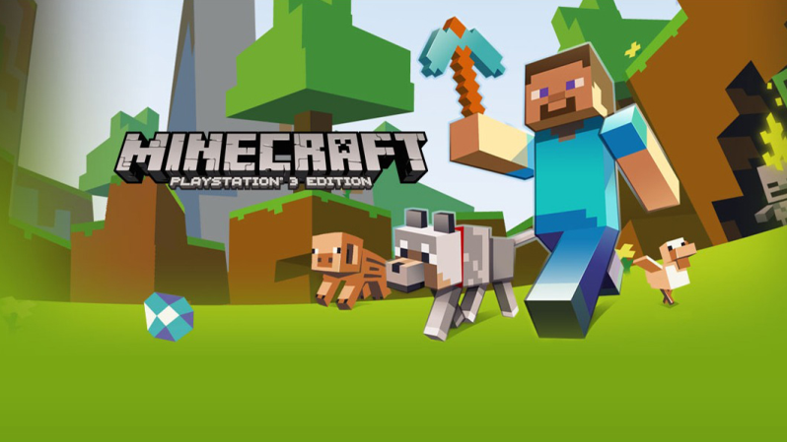

Minecraft being created with a small team behind it and a very basic look did not seem interesting when released but soon gained a huge following that continues to grow to this day because of how great and addicting the gameplay is.

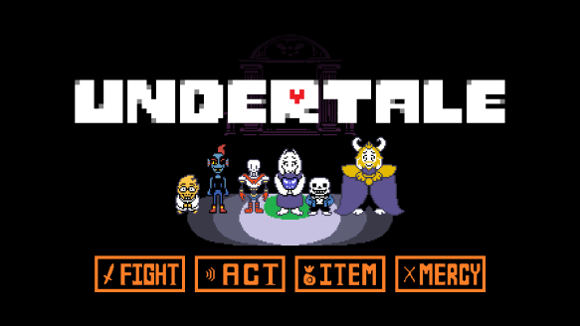

Undertale a game that was only released recently on September 15Th 2015 by two people would at first glance give a player an idea of a simplistic, retro kids game but as this document is being written it still grows among the gaming community as a charming game that intrigues players and offer several different choices and outcomes. These go to show that the look of a game will not define it and gameplay is important more so than graphics.

**Other Technical Aspects**

The tools we decided to use have been chosen due to the fact that we will not be limited to using only one piece of software and due to the fact that we will be creating some of our own resources and game elements it is needed that we develop using several tools rather than one.

**Unity**

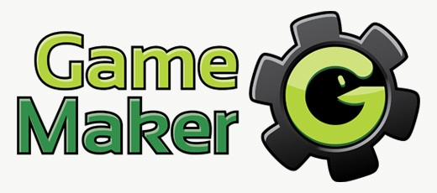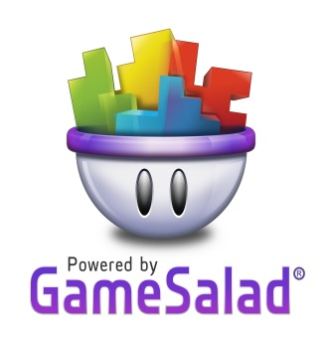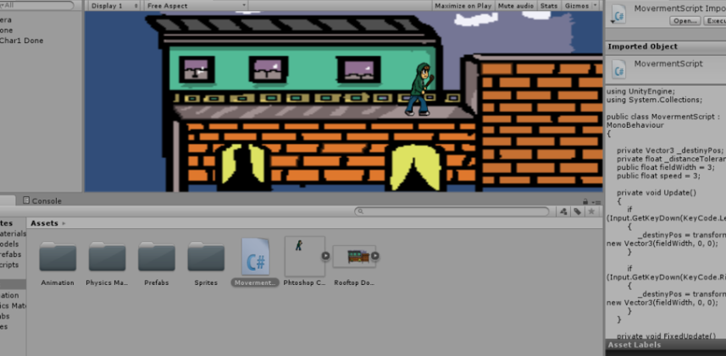Unity is a powerful development platform used for creating 3D and 2D games. Unity also comes in a free personal edition giving just the basics but enough to help us develop and create our game. Though there are other engines out there that we could have chosen from such as GameMaker and Gamesalad we have chosen Unity due to the fact that it has a good reputation for game creation among the game development community and also because of the amount of documentation regarding the different way to use it, from the very basics to more advanced lessons and tutorials. Unity uses both C++ and C#, with more emphasis on C# we will be learning the way to code along with the different tutorials and effectively use these languages. Granted we have not covered C# it has been reported in other forums that it is better suited for use with Unity and general game development. All of our coding will be pieced together in Unity the engine, levels and controls. Unity will be our main operator for the creation of the game and where we will work most.

**Photoshop**

Adobe Photoshop is predominantly photo editing and manipulation software though is widely known for its use in digital art also. We will be using this software in order to create the graphical design aspect of the project, creating backgrounds, characters and other objects within the game.

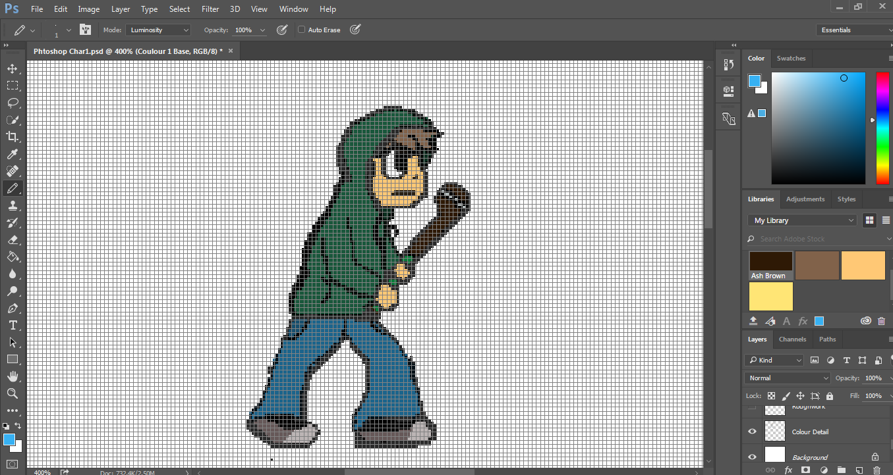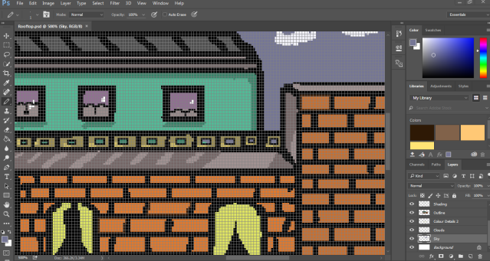

We have already prepared templates that use a drawing style with grids that is perfect for pixel art development. Using this we will easily be able to work on the designs for the different graphics of the game. We hold a small bit of experience using Photoshop and will be learning more as the project progresses.

**Audacity**

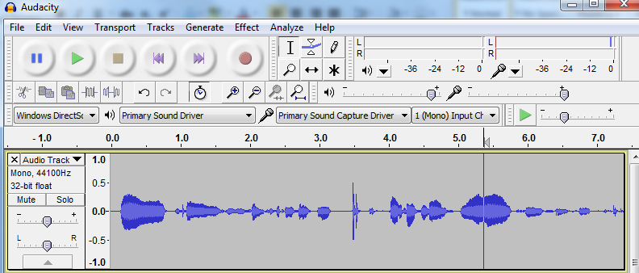Audacity is a free open source digital audio editor and recording software. The use of Audacity within the project may vary depending on the need for various sound effects and tracks. Using audacity we can change the sound of different elements whether they are recorded or sourced from somewhere else. This way we can edit these sounds to suit the game better as we see fit and only export them all into the same files types that will fit the project better, optimised to create less overhead.. Though we plan on to mostly source of sound material we can see the uses of this software and so using it will be beneficial. We have some experience already using Audacity and know some basics of making audio sound clearer and editing to create different effect so having this experience will prove useful.

**Hardware & Other Requirements**

At the moment of the development of the project it is relatively unknown as to the requirements that the game will need for it to run, though we will definitely be looking into downsizing the needed requirements so that it is available among other computers and not just high end PCs.

It is worth mentioning that a graphic tablet will be used when it comes to the development of the design of the game along with Photoshop, the Wacom Intuos Manga is a small drawing graphic tablet used for digital design. This piece of hardware will definitely help us with designing the games looks through Photoshop.

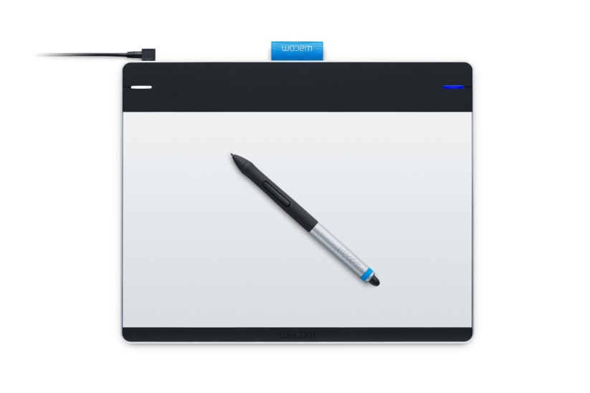

As of yet the games prototype only has some basic functionality as a foundation for the game. Once we work out basic movements and other key elements needed for the basis of the game we can then focus on the several ideas we have for the game.

We have however been gaining people to help with the testing of the game. These game testers will prove to be very useful as to help us gain knowledge of bugs, new ideas and the overall impact the game has on the player with regards to its playability and fun factor. Through social media we have posted a notice inviting people to sign up to test the game. These testers can range from those who we can meet in person and those who will be sent prototype of the game due to their location and inability to meet in person. All testers will be required to accept special terms through a form which once agreed to will mean that they cannot claim ownership of any part of the game for themselves and will respect the decisions made by us. All information learnt from this experience will help in our development as we believe learning from a non-biased group will give us proper advice as to what works and what doesn’t and help us manage our resources and time on things that the players like and dislike.

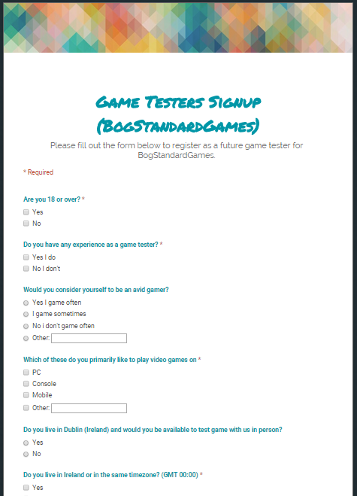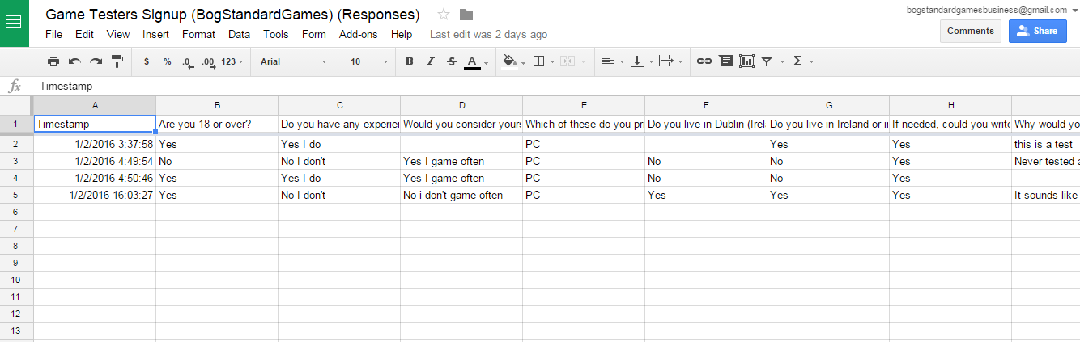

Another idea we have chosen to test out will be live development of the game through streaming services. The service we will be using for this will be Twitch, an online social video platform and a community for gamers. This platform caters to the entire video games industry including game developers and publishers. Game developers have used this platform already in the past the showcase their games development and gain feedback from the gaming community. By streaming our games development we can not only gain feedback as to suggestions and what people think of certain elements being added live we can also document video footage from the game development process for documentation and viewing also if needed.



At this moment in time the only controls for the game will be keyboard controls, we have not decided whether or not to include a porting to external game pads and devices but at the moment have chosen to keep things manageable given there is so much to focus on already. It is unknown whether or not future implementation of this will be made but if so it will be done at a very later stage when the game itself is playable from keyboard controls with ease.

**Final Thoughts**

The development of this game will prove to be a challenge no doubt. Learning new methods of coding, different programs and design will need a lot of resources and effort put in but we believe that by sticking to an organised schedule and keeping track of its development we can make it happen. The project will demand a lot of effort but this is expected with what we are making, nothing about this will be easy and as it should be.

We have a deep passion for this project and with confidence in our abilities and this passion for the game we believe we can accomplish the goals we set.

**Bibliography**

Other Game Engines - http://www.develop-online.net/tools-and-tech/the-top-16-game-engines-for-2014/0192302

Unity tutorial - <https://www.youtube.com/watch?v=4qE8cuHI93c>

What is Unity - <https://unity3d.com/unity>

What is Photoshop - <http://www.washington.edu/itconnect/learn/workshops/online-tutorials/graphics-and-design-workshops/adobe-cs/photoshop/>

What is Audacity - http://audacityteam.org/about/

What is Twitch - http://www.twitch.tv/p/about